

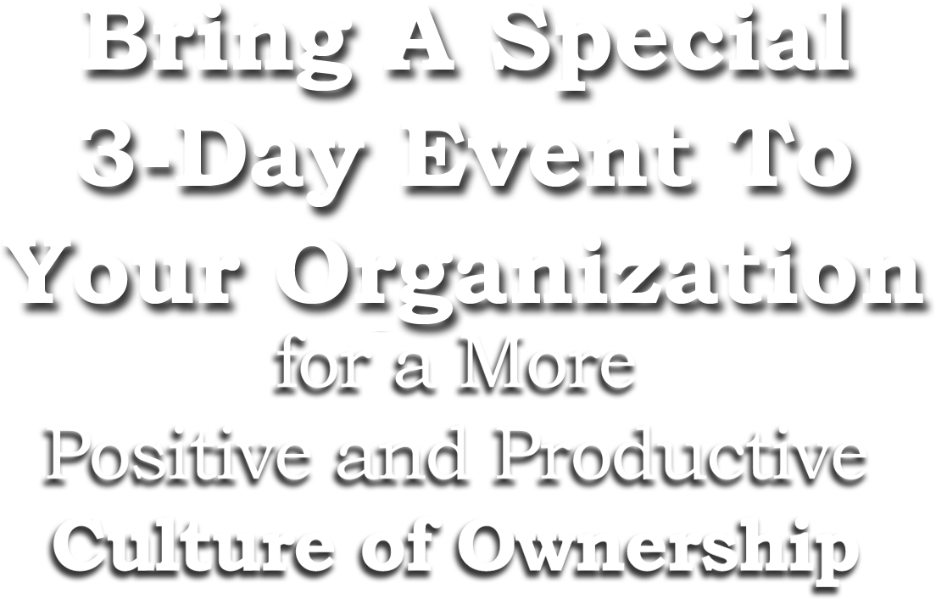

It’s often said that culture eats strategy for lunch. Your hospital has a strategic plan, but do you have a culture plan? This 3-day event will challenge your leadership team to create a blueprint for your Invisible Architecture™ of core values, organizational culture, and workplace attitude, and challenge your people to be more emotionally positive,

self-empowered, and fully engaged in their work.

“I got a whole new team and didn’t have to change any of the people.”

*Paul Utemark, Chief Executive Officer*

*Fillmore County Hospital, Geneva, Nebraska*

**Before the Event**

* Conference call with leadership planning group.
* Culture Assessment Survey administered.
* *Cultural Blueprinting Toolkit Workbook* and *The Florence Prescription* books delivered.
* Dinner meeting with leadership team evening before the management retreat.

**Day 1: Management Retreat on Creating a Cultural Blueprint for**

**Your Invisible Architecture™**

A full day interactive session committed to sparking a dialog about your Invisible Architecture™ of core values, organizational culture, and workplace attitude, with special focus on how to more effectively use these for recruiting and retaining great people, inspiring great performance, and establishing a sustainable source of competitive advantage.

**Days 2-3: Employee Presentations on The Florence Prescription**

Series of 90-minute presentations for all employees summarizing results of Culture Assessment Survey, describing essential characteristics of a culture of ownership, and sharing values-based life and leadership skills. This can include special sessions for board members, medical staff, or other key groups. *Optional:* We can also schedule a special evening program for employees’ family members and the community at large.

**After the Event – to Make Sure it’s “More than a Pep Rally”**

* Consulting summary of observations and recommendations.
* Six one-hour webinars on each chapter of the *Cultural Blueprinting Toolkit Workbook*.
* Subscriptions to *Spark Plug* email newsletter.
* Follow-up resources at [www.TheFlorenceChallenge.com](http://www.TheFlorenceChallenge.com) includes study guide, eBooks, webinars, and other materials – all are free.
* Organizational discount on the Values Coach PledgePower online course.

**Your Schedule**

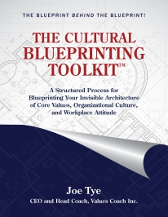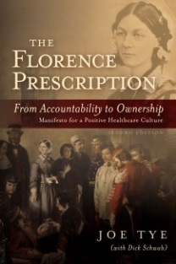

*“The first day leadership retreat challenged us to think concretely about our core values and organizational culture – and to make sure everyone on our executive team was on board. Joe’s employee presentations created a tremendous buzz and have inspired our people to take to heart the various self-empowerment tools he shared. And his presentation to the community was great PR for the medical center. Having Values Coach create an event for your hospital is, I believe, one of the best investments you can make to help you thrive in today’s challenging environment.”*

*Charlie Button, President and CEO  
Star Valley Medical Center, Afton, Wyoming*

**The Florence Commitment**

One of the many resources on The Florence Challenge website ([www.TheFlorenceChallenge.com](http://www.TheFlorenceChallenge.com)) is a downloadable Certificate of Commitment. By signing this form, people are making a personal commitment to be more Emotionally Positive, Self Empowered, and Fully Engaged. And when everyone in a department or on a patient care unit makes that commitment it has a profoundly positive impact on both employee morale and patient satisfaction.

**Special Features**

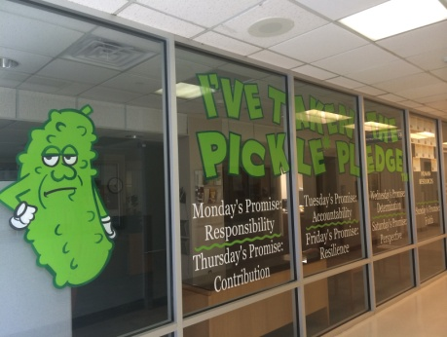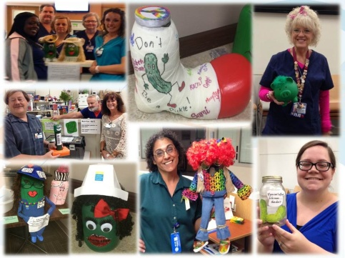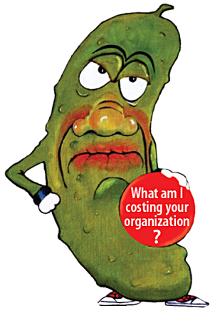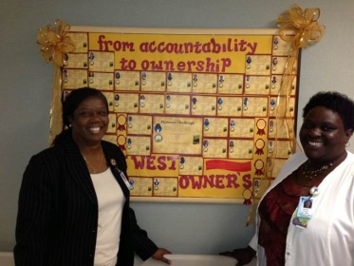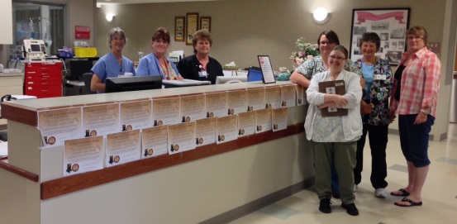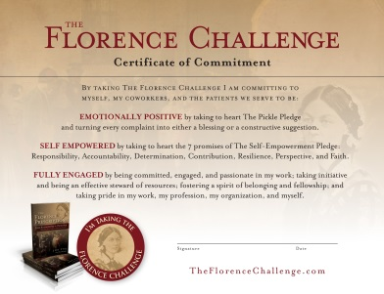

**Midland Memorial Hospital**

**Human Resources office**

**Midland Memorial Hospital**

**Pickle Jar Decorating Contest**

“Our engagement with Values Coach has resulted in substantial productivity savings, measurably enhanced morale, and record high patient satisfaction scores, but the most important benefit has been the impact on helping individual employees change their lives for the better.”

*Bob Dent, Senior Vice President/Chief Operating Officer*

*Midland Memorial Hospital, Midland, Texas*

**The Pickle Challenge**

One of the simplest and yet most powerful cultural transformation tools included in this program is The Pickle Challenge. When people make a commitment to this simple promise it does more than help them be better at work – it helps them be happier at home. Many hospitals include a pickle jar decorating contest in the program and invite people to deposit one quarter each time they catch themselves or someone else complaining about something.

When we start working with a client on a values and culture initiative, one of the first things we do is conduct a Culture Assessment Survey. Based upon how people respond to some of the questions, we estimate the amount of money that the organization is paying people for the time they spend complaining, gossiping, and other forms of toxic emotional negativity. Depending upon the size of the organization that dollar cost can range from hundreds of thousands to millions of dollars per year.

Within a 4-month period Midland Memorial Hospital redirected **more than $7 million** in wage and salary expense from toxic emotional negativity into more positive and productive uses. The percentage of employees agreeing with the statement “We treat others with respect and refrain from toxic emotional negativity” nearly doubled between February and August 2014. As a result, employee morale and patient satisfaction are both now at all-time highs.

**The Self-Empowerment Pledge**

The Self-Empowerment Pledge features seven simple (simple but not easy) life-changing promises – and when a critical mass of individuals within a unit or department collectively commit to those promises it can have a profound cultural impact. Hospitals are using the Pledge posters as screensavers, having an operator repeat the promises on the overhead paging system, inviting people to share their own stories about how these promises have helped them, and a whole lot more. Wristbands for each of the seven promises serve as great personal reminders.

These individual posters make great daily screensavers! Imagine the impact it could have on your organization if your people all made a good faith effort to live these promises in their work and in their lives!

**Special Features cont.**

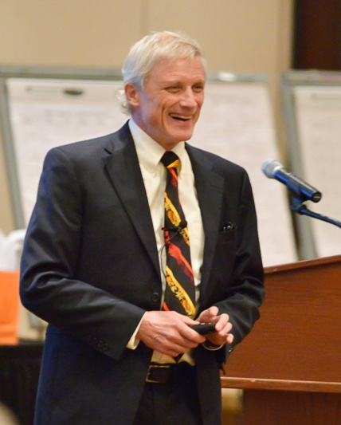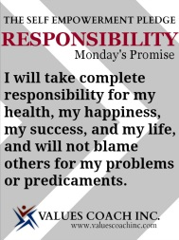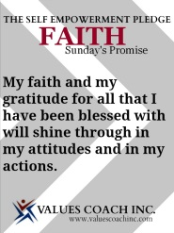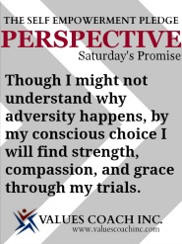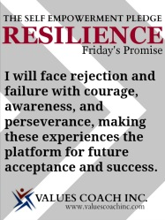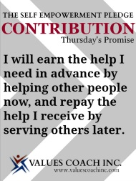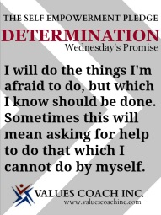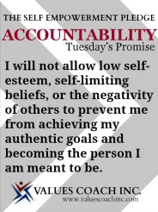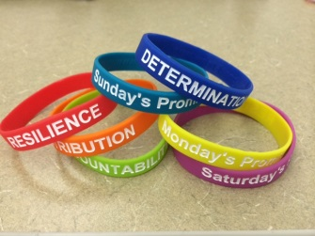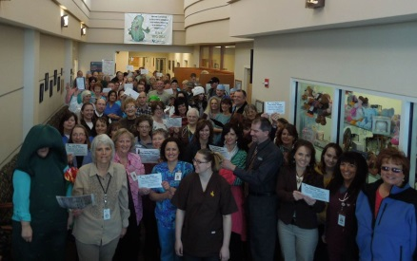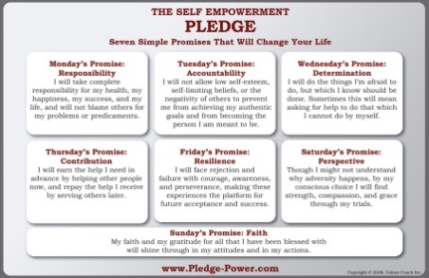

Joe Tye is CEO and Head Coach of Values Coach Inc. Prior to founding Values Coach in 1994 he was chief operating officer for a 700-bed hospital.

Joe is a leading authority on strategies to foster a culture of ownership in healthcare organizations and a frequent speaker on values-based life and leadership skills and cultural transformation. He is the author of more than a dozen books on personal success and organizational effectiveness.

Joe will challenge your team, he will inspire your people, and help you be a better organization.

“Bringing the 3-Day Culture Shift Event to Kalispell Regional Healthcare is one of the best decisions I've made in 23 years.  There is an incredible level of enthusiasm and we are already seeing a positive impact throughout the organization.  We especially appreciate the tools that will help us sustain our momentum.”

*Deb Wilson, Chief Operating Officer*

*Kalispell Regional Healthcare, Kalispell, Montana*

**About Your Presenter**

**Contact Values Coach**

**Here are just a few of the benefits you will achieve:**

* The culture assessment survey will provide you with a unique window into employee perceptions of your organization’s culture.
* Members of your management team will be able to more clearly articulate the “blueprint behind the blueprint” for your Invisible Architecture™ of core values, organizational culture, and workplace attitude.
* You will have a game plan for fostering a stronger culture of ownership with the 8 essential characteristics described *The* *Florence Prescription*: commitment, engagement, passion, initiative, stewardship, belonging, fellowship, and pride.
* The Self Empowerment Pledge, The Pickle Challenge, and other activities will help you to promote a more positive attitude in the workplace and raise the level of intolerance for toxic emotional negativity.
* As a direct result of enhanced employee engagement and commitment to positive attitudes you will see improved patient satisfaction.
* Supplemental resources provided before, during, and after the event will help you assure lasting impact and avoid “program of the month” syndrome.
* You will hear from some of your people that their participation in this program has had a life-changing impact, and those individuals will become the “spark plugs” who help you accelerate the movement for a more positive and productive culture of ownership.
* But don’t just take our word for it: we will be happy to connect you with our other clients.

**Phone: 800-644-3889/319-624-3889**

Email: [Michelle@valuescoach.com](mailto:Michelle@valuescoach.com)

Jordan Creek Plaza, Suite 400

P.O. Box 490

Solon IA 52333-0490

**Visit us online**

[www.ValuesCoach.com](http://www.ValuesCoach.com)

[www.TheFlorenceChallenge.com](http://www.TheFlorenceChallenge.com)

[www.PledgePower.com](http://www.PledgePower.com)

[www.ValuesCoach.com/case-studies](http://www.ValuesCoach.com/case-studies)

**Benefits**